RETIREMENTTRACK
Product Requirements & User Workflow Definition

1. Purpose and Scope
Goal: Translate the product vision into buildable, testable user behavior for the first credible MVP without prematurely designing the technical architecture.
Product vision: A white-label retirement education, assessment, and ongoing-engagement platform for professional firms and clients approaching or living in retirement.
MVP principle: The MVP should not feel like a generic library of forms and retirement resources. The client experience should use known client context, life stage, assessments, circumstances, completion history, and firm/advisor inputs to present a small number of relevant next actions, content, and planning opportunities.

1.1 What the product is intended to prove
• Clients can understand where they are, what is complete, what needs attention, and what is relevant next.
• Assessments, Planning Updates, education, reminders, and selected benchmarking can participate in one coherent client experience.
• Advisors can see activity, exceptions, changes, and follow-up needs without manually reviewing every client.
• Recurring engagement creates meaningful reasons for clients and advisors to return over time.

2. User Roles
Role | First-Build Responsibility | Access Boundary
Client | Complete assigned activities; review status, relevant content, reminders and supported results; return for ongoing engagement. | Own profile and assigned client experience.
Advisor | Invite/manage assigned clients; assign/recommend activities; review results/changes; approve selected communications; perform follow-up. | Authorized/assigned clients within the firm.
Firm Administrator | Manage firm users, basic branding, feature availability, communication behavior, content visibility and supported advisor/client governance. | Own firm/tenant only.
Platform Administrator | Manage tenant setup/status, common content/configuration and operational support. | Platform administration with limited tenant/client data access.

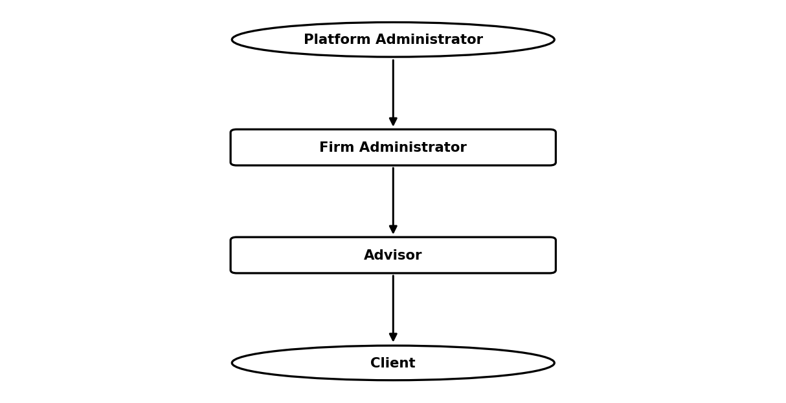

3. Client Experience
Client outcome: The client should feel that RetirementTrack knows enough about their stage and activity to present a purposeful next step, not a generic library of retirement resources.
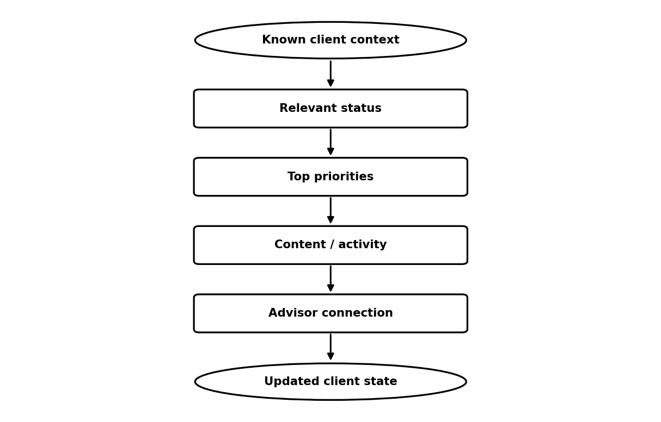

First-Build Client Experience | Later / Expanded
Personalized opening; simple planning status; completed/outstanding work; a small attention list; assessments; Planning Updates; relevant education; reminders/milestones; advisor identity; continuity between visits. | Sophisticated AI recommendations; large dynamic content journeys; complex retirement-readiness scoring; highly configurable client journeys.

4. Client Onboarding Flow
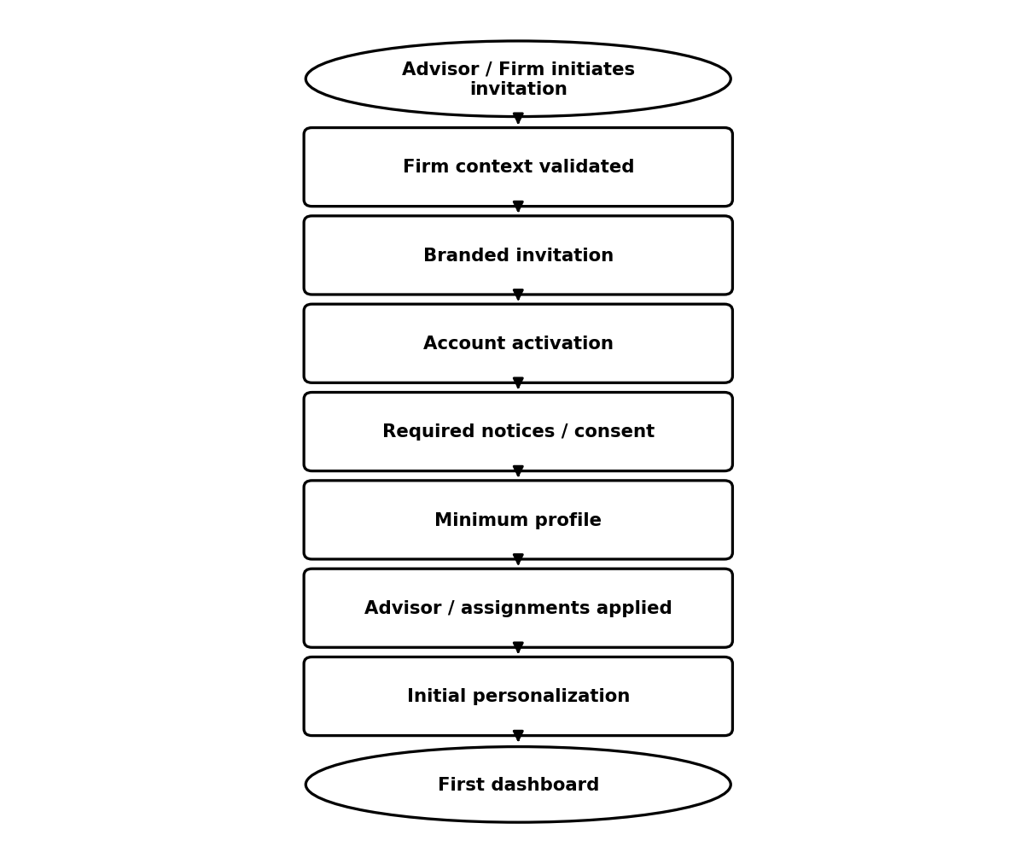

4.1 First-Build behavior
• Collect only the minimum profile/context required to make the first dashboard useful.
• Establish the correct firm and advisor relationship before the client reaches the dashboard.
• Show a useful starting state even when personalization data is limited.
• Retain basic invitation, activation, consent and onboarding status/history.
• Avoid unsupported benchmark or planning conclusions when required inputs are missing.

4.2 Product decisions to confirm
• Exact invitation expiration/resend policy.
• Exact terms/privacy/communication-consent requirements.
• Whether Firm Administrator and Advisor both create/invite clients.
• Minimum age/life-stage fields required at activation.
• Behavior for existing accounts, duplicate clients, multiple firms/advisors.

5. Client Dashboard Requirements
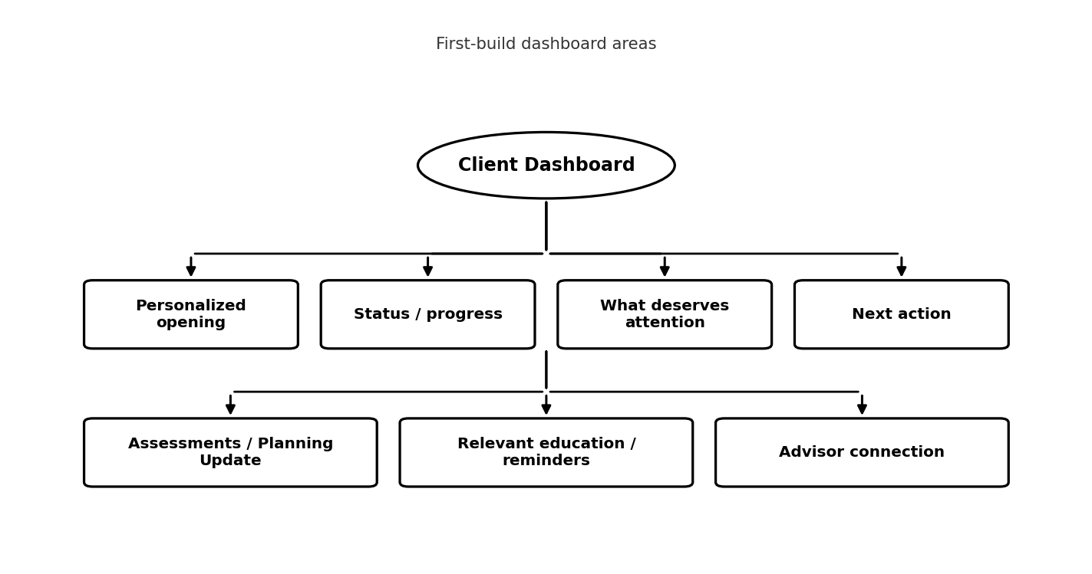

Dashboard Area | First-Build Requirement
Opening | Client identity, firm branding, advisor identity, retirement/life-stage context where supported.
Status / progress | Simple completion/status indicators; do not imply a comprehensive planning score unless methodology is defined.
What deserves attention | A small prioritized set, approximately a few high-value items, based on defined rules.
Activities | Assigned assessments, Planning Updates, advisor-requested items.
Relevant content | Content surfaced because of known context, not only via a static library.
Reminders / milestones | Basic due/date/age/event items where enabled.
Benchmarking | Only when enabled and supported by validated inputs/methodology.
Continuity | Reflect what was completed, what changed and what is relevant now.

6. Advisor Experience
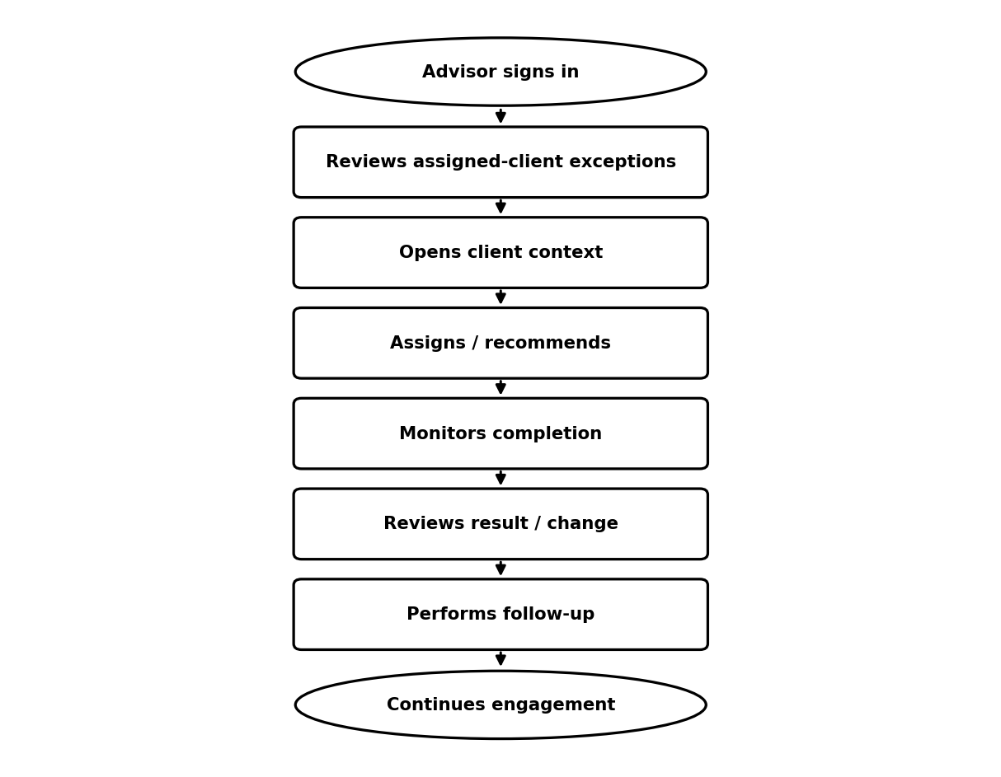

• Focus the first build on actionability rather than broad analytics.
• Keep professional judgment with the advisor; RetirementTrack surfaces conditions and context rather than individualized advice.
• Allow assignment/recommendation only for product capabilities enabled by the firm.
• Provide enough history to understand what was sent, completed, changed and followed up.

7. Advisor Dashboard Requirements
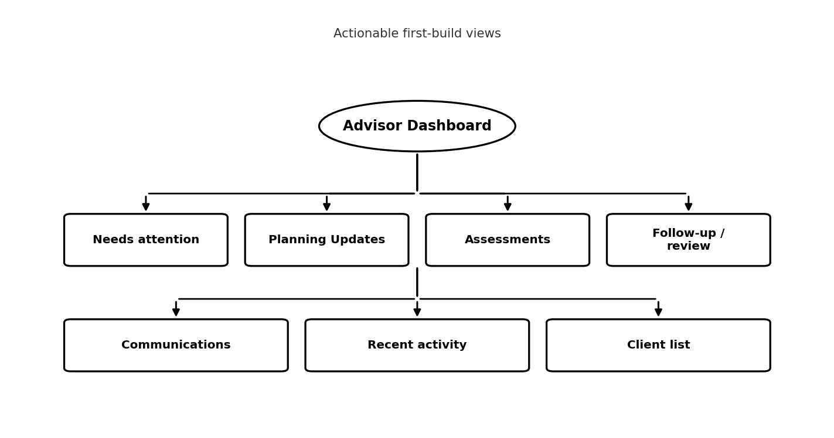

Area | First-Build Use
Needs attention | Meaningful changes, notable outcomes, overdue items, pending approvals and defined follow-up conditions.
Planning Updates | Upcoming/due/completed/overdue/changed state where applicable.
Assessments | Assigned/in progress/completed and review-needed state.
Follow-up | Simple open review items; completed/dismissed items move to history.
Communications | Pending approvals plus basic sent/history visibility.
Client list | Search/filter sufficient for the assigned-client workflow.
Analytics | Deferred beyond essential operational counts/status unless client makes it launch-critical.

8. Firm Administrator Experience
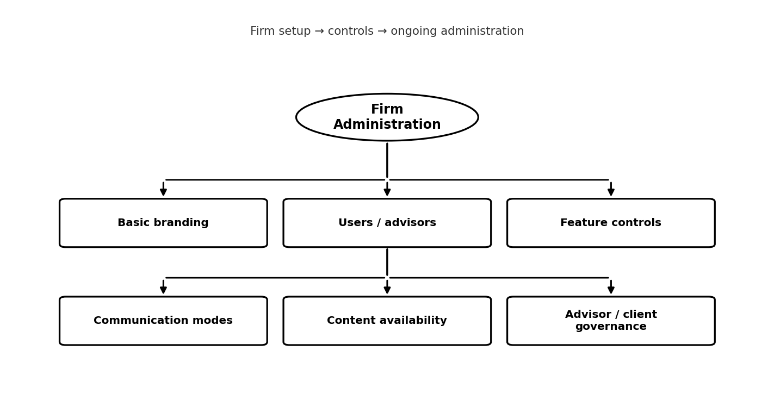

Control | First-Build Direction
Branding | Firm name/logo and selected basic brand/advisor identity settings.
Features | Enable/disable supported modules such as Planning Updates, assessments, benchmarking, education and reminders.
Communications | Automatic / Advisor Approval / Off for supported communication types.
Content | Control availability of platform-provided content/resources.
Users | Manage firm users/advisors under the final role model.
Client-level overrides | Only where clearly needed; firm-disabled features should not be silently re-enabled per client.

9. Platform Administrator Experience
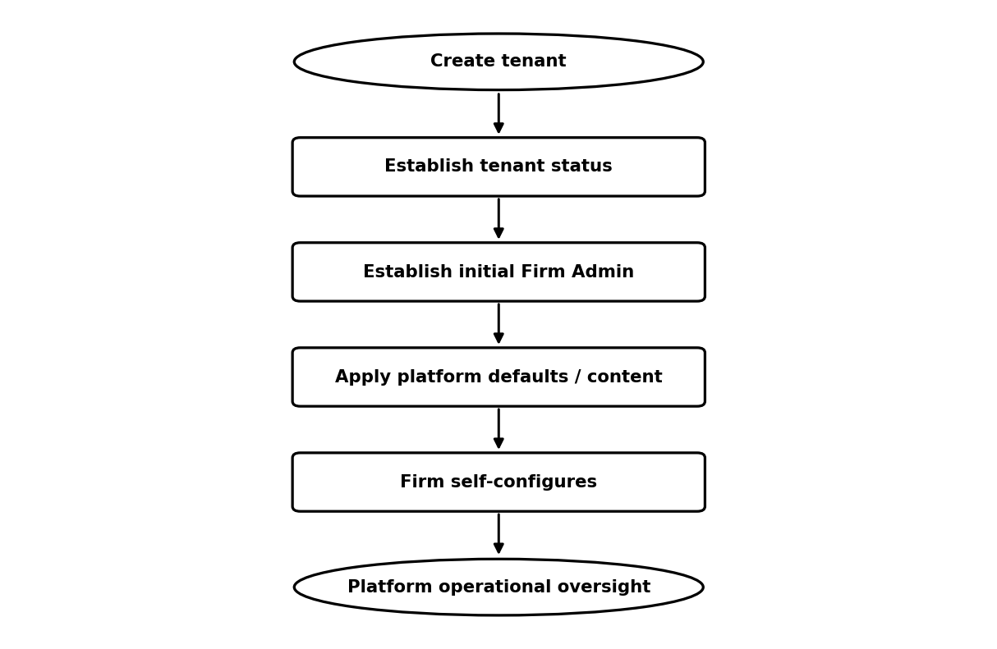

• Manage tenant/firms, tenant status, common content and supported platform defaults.
• Support operational troubleshooting without becoming part of ordinary advisor-client workflows.
• Keep direct access to sensitive client details restricted by default.
• Maintain basic administrative/audit visibility required for tenant operations.

10. Assessment Workflow
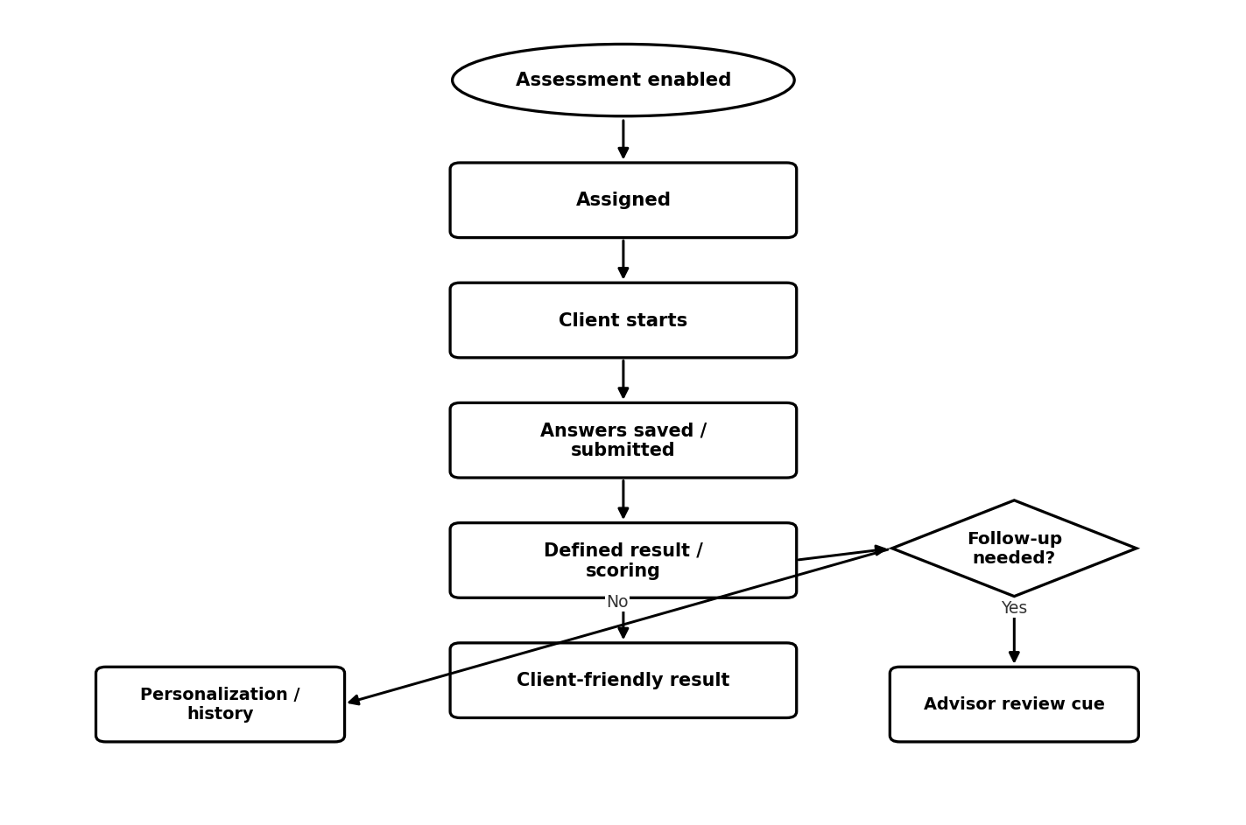

First Build | Not Assumed / Later
Small number of structured assessments; risk assessment is a likely example; readable results; defined scoring/category logic; educational context; advisor follow-up cue. | General-purpose assessment builder; dozens of assessments; firm-customizable forms/workflows; broad report engine.

11. Planning Update Workflow
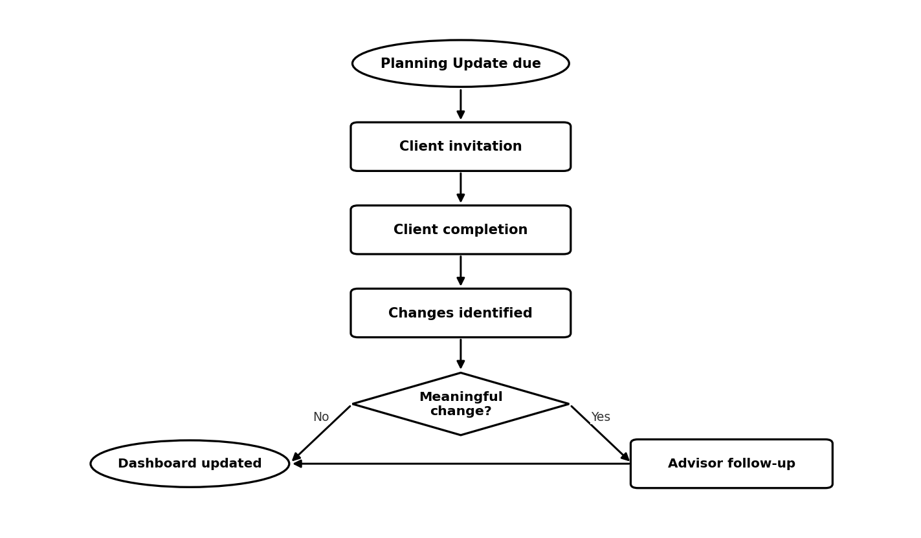

11.1 First-Build intent
• Treat Planning Update as a core recurring-engagement workflow.
• Use a deliberately narrow initial form/state model rather than a configurable workflow engine.
• Compare current information with relevant prior state to identify defined changes.
• Only create advisor attention when business rules identify a meaningful change.
• Update client state/history after completion.

12. Recurring Engagement Workflow
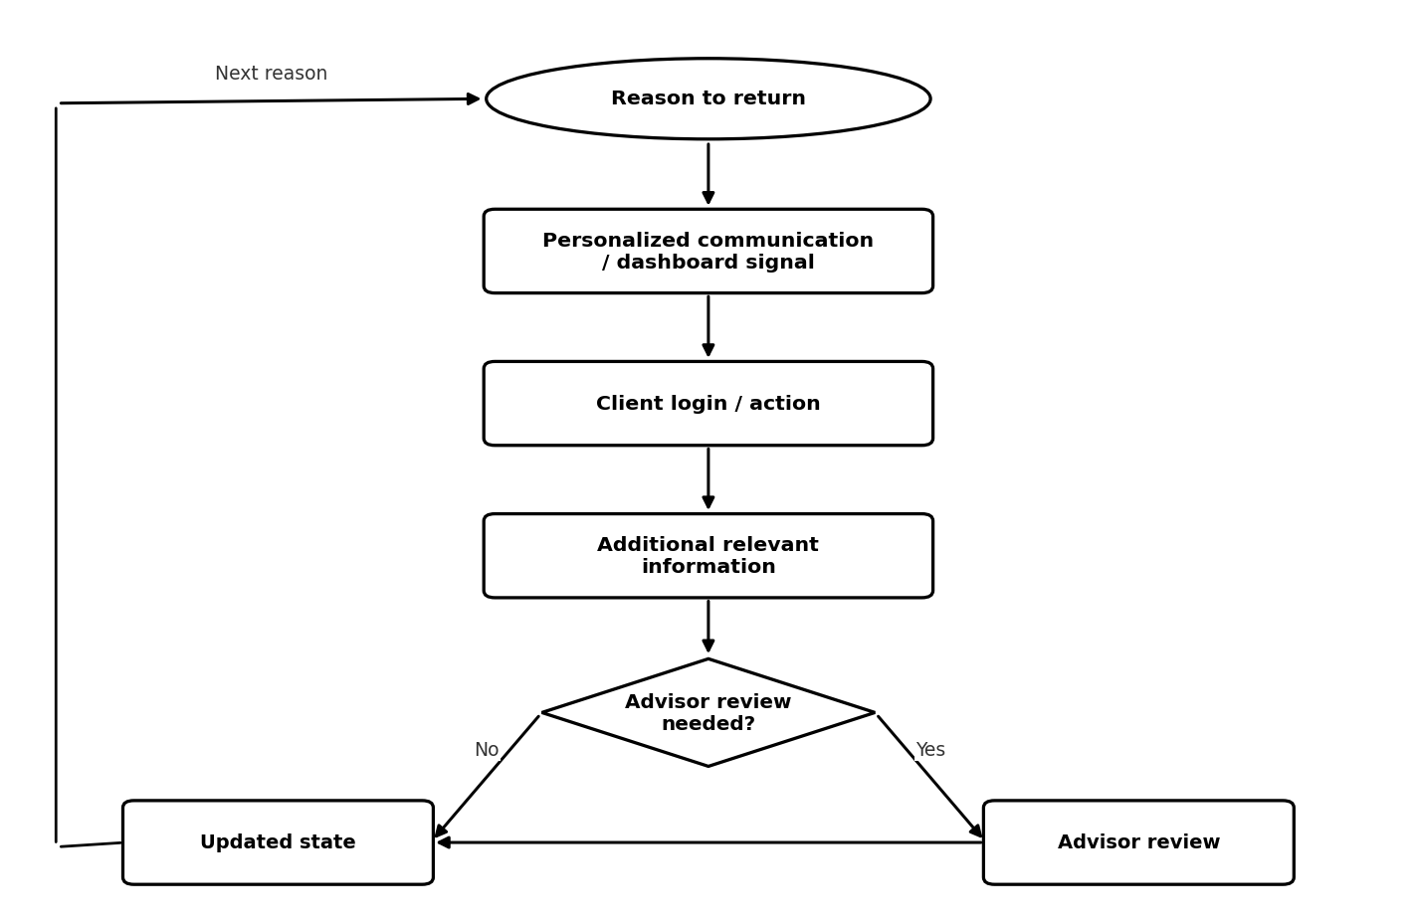

First-build triggers may come from: Planning Update due/overdue, assessment assignment/completion, advisor assignment, age/life-stage milestone, newly relevant content, or a defined change/opportunity. Exact trigger inventory is still a Product Decision.
Automate in First Build | Keep Advisor-Controlled
Due/status calculations; basic reminder scheduling; completion/state tracking; simple personalization rules; defined change/follow-up creation; communication history. | Professional interpretation; individualized advice; complex recommendations; arbitrary campaign creation; custom workflow/rule authoring.

13. Communication Workflow
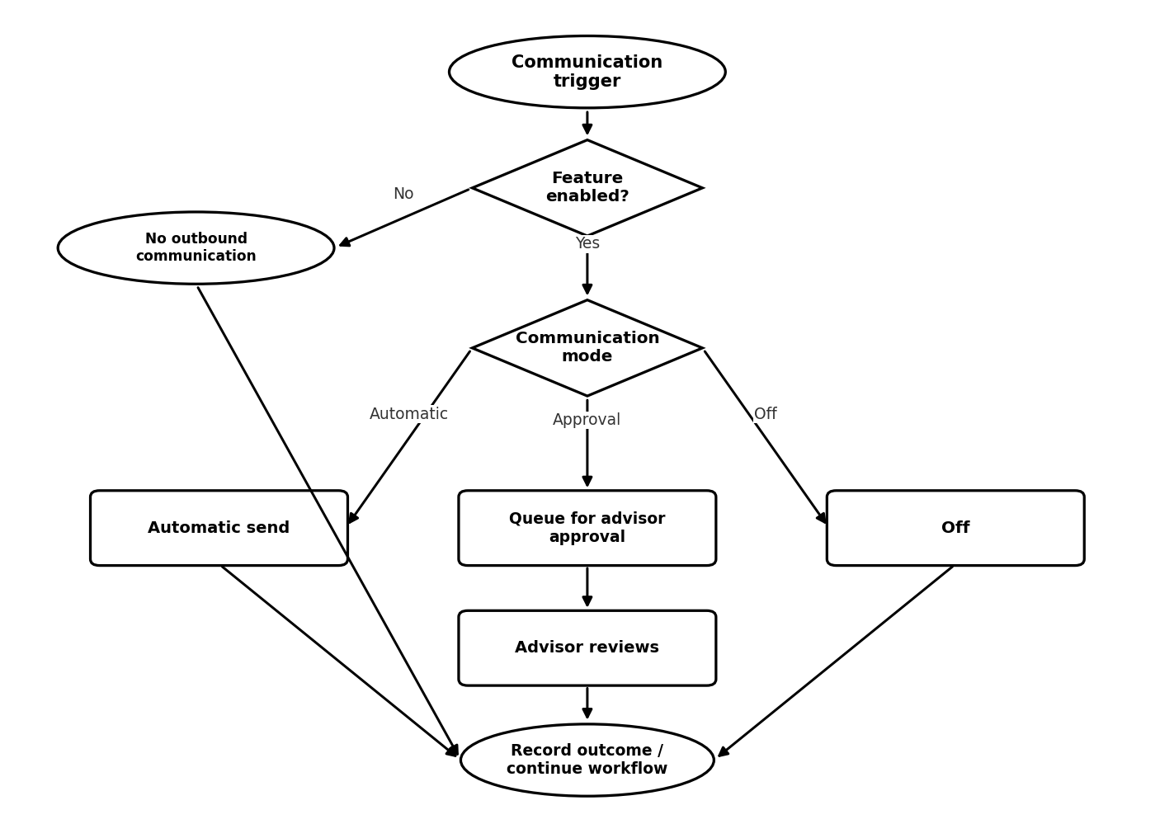

Mode | Behavior
Automatic | Send when the defined condition occurs.
Advisor Approval | Prepare/queue; advisor reviews before send.
Off | Do not send outbound communication for that scenario.

Likely first-build communication use cases: Onboarding invitation, Planning Update invitation/reminder, assessment assignment/reminder, selected milestone/general planning reminders where defined.

14. Advisor Review / Follow-Up Workflow
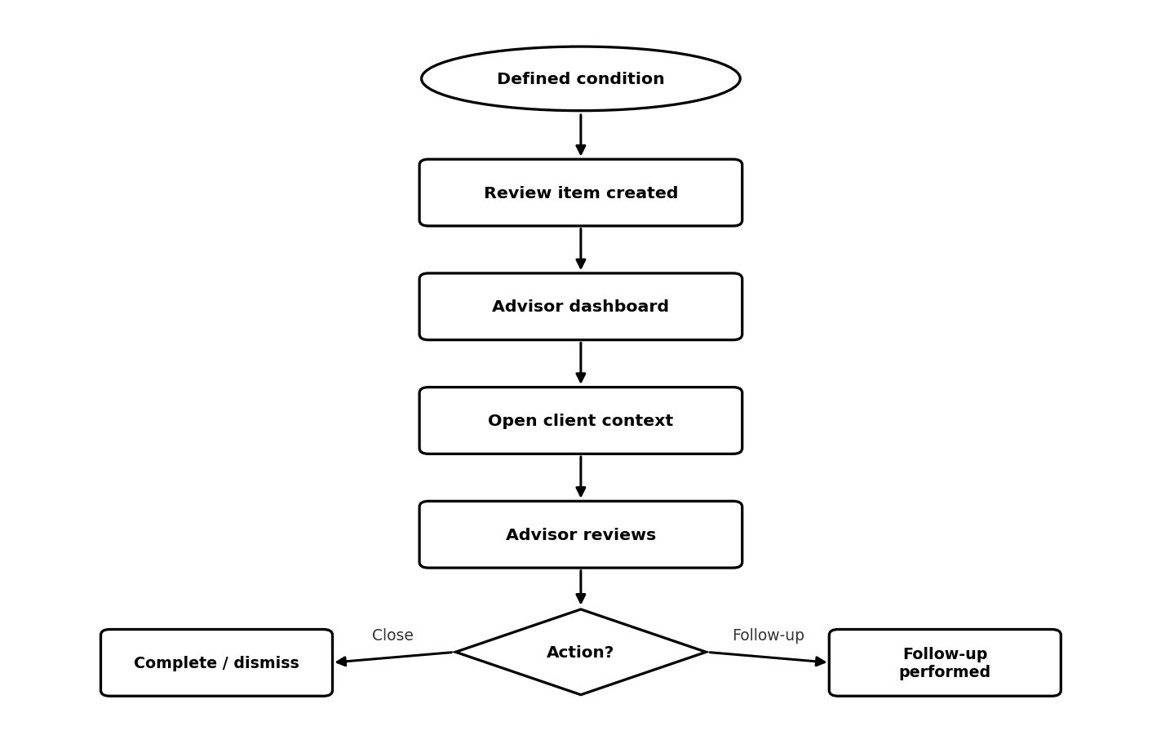

First-build principle: A simple review lifecycle is enough. RetirementTrack should surface why attention is needed without turning into a full CRM/task-management platform.
Potential Trigger | First-Build Treatment
Meaningful Planning Update change | Create advisor review item when rule is defined.
Assessment result condition | Create review cue when methodology/business rule requires it.
Pending communication approval | Show in advisor work queue.
Overdue/incomplete client item | Only create follow-up if the business rule says advisor attention is warranted.
Routine completion | Record as activity; do not automatically create noise.

15. Educational Content Delivery Workflow
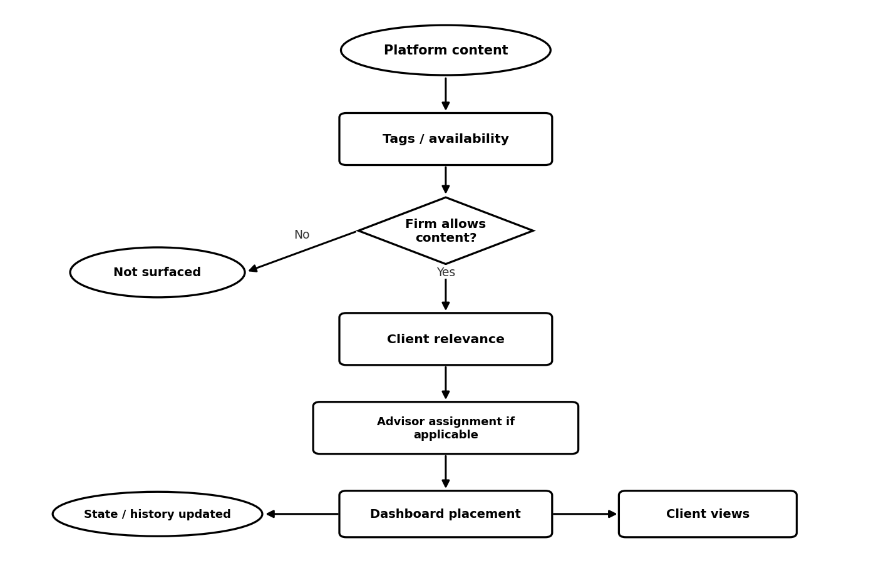

First-build content: Platform-provided articles, videos, resources and other approved educational items, with enough tagging to support simple relevance and firm visibility controls.
Later-phase capability
Firm-specific authoring/uploads, sophisticated recommendation engines, complex campaign journeys and large content-personalization taxonomies should not be assumed for the first build.

16. Reminder Workflow
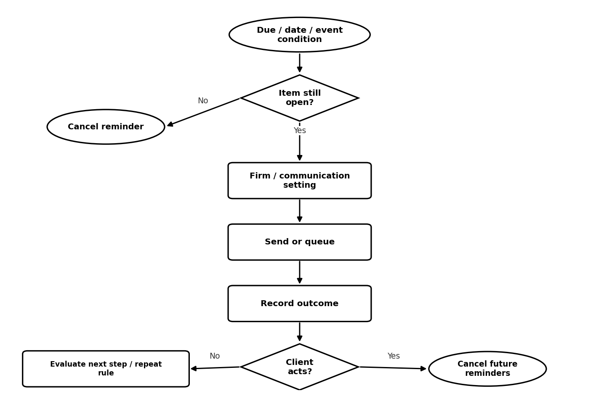

16.1 First-Build reminder scope
• Basic age/date/event reminders as described in the Discovery Brief.
• Planning Update and assessment reminders where selected for MVP.
• Noise controls: no reminder after completion, avoid duplicates, limit repeated reminders.

17. Benchmarking Workflow
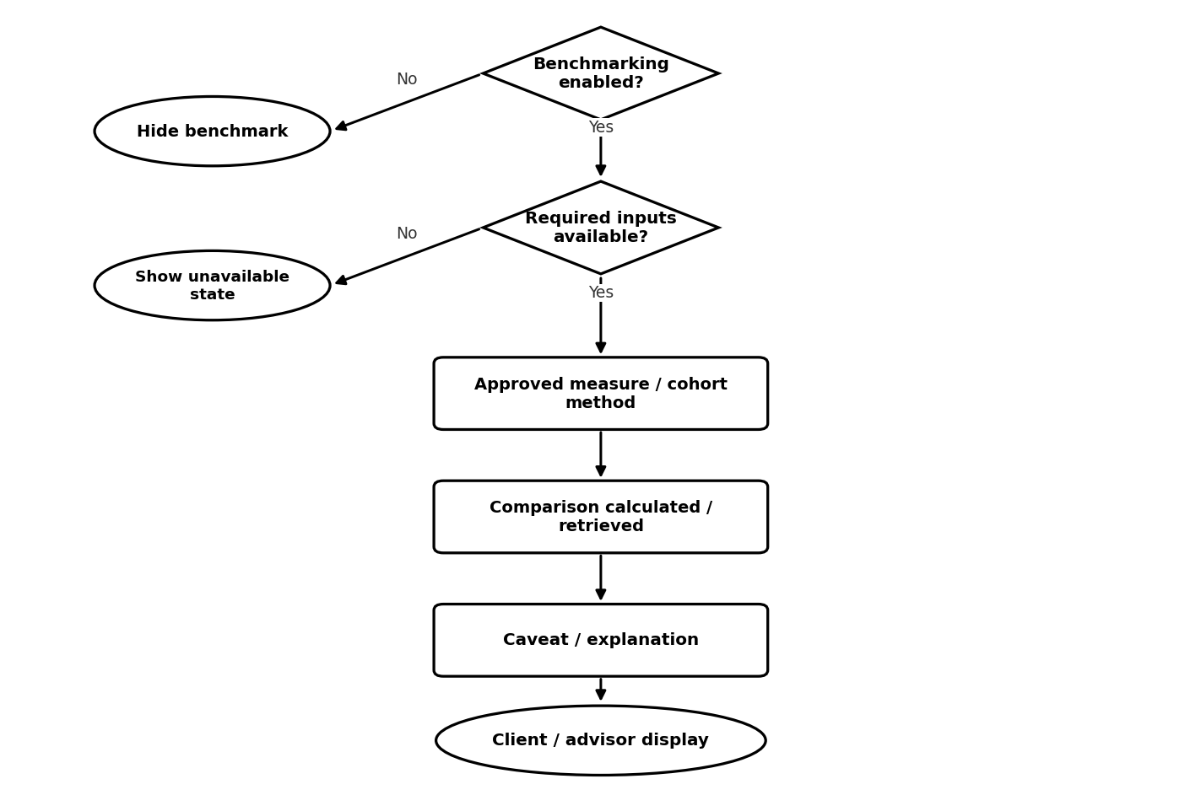

MVP position: Benchmarking remains part of the stated product vision. However, the first build should only include a simplified benchmark experience if credible measures, data source, cohort methodology, privacy rules and caveats are validated during Discovery.
Do not assume: Live cohort analytics, complex historical benchmarking, sophisticated readiness scoring, or benchmark-driven financial recommendations.

18. Personalization Workflow
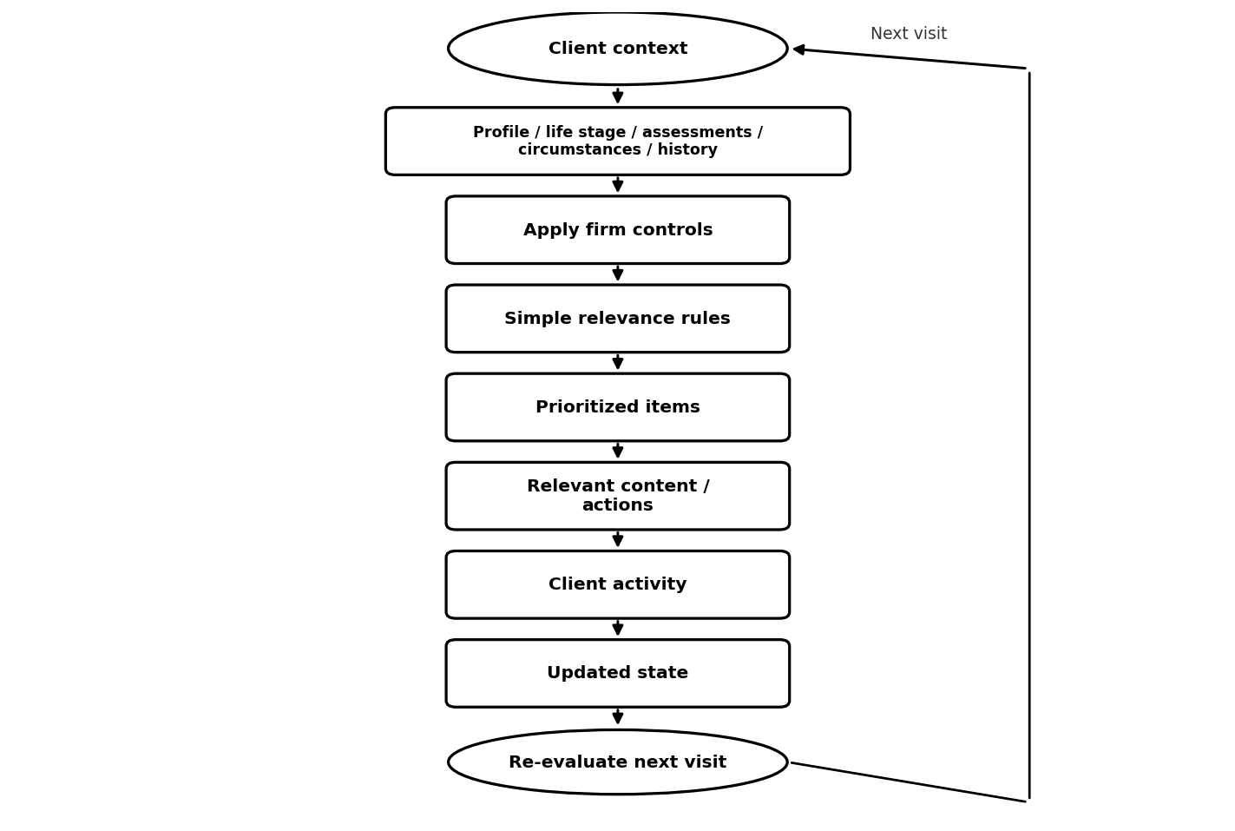

Belongs in First Build | Later / Avoid Overbuilding
Personalized opening; age/life-stage relevance; assessment-driven relevance where rules exist; small “what deserves attention” list; dynamic education; progress/continuity; advisor connection. | AI/ML recommendation engine; complex segmentation; firm-authored rule builder; large configurable decision engine.

19. Role / Permission Requirements
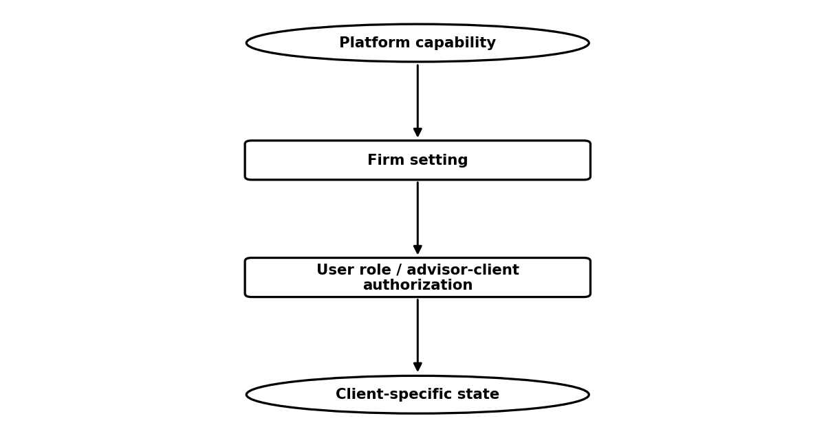

Role | Core First-Build Permissions | Must Not Assume
Client | Own profile/experience; complete activities; view supported results/content/status. | Access to other clients or administration.
Advisor | Assigned clients; assignments; review/change context; approvals; follow-up/history. | All firm clients unless authorized; firm/platform settings.
Firm Admin | Firm users, branding, feature/communication/content controls, supported governance. | Unrestricted sensitive client data by default; other tenants.
Platform Admin | Tenant/status/content/configuration/operational administration. | Routine unrestricted client financial/assessment access.

20. Key Edge Cases
Area | First-Build Edge Cases to Handle
Onboarding | Expired/wrong invitation, duplicate record, abandoned onboarding, missing context, advisor change before activation.
Tenant / relationship | Unauthorized/cross-tenant access, advisor transfer, firm suspension, multi-firm/multi-advisor requests.
Assessments | Incomplete attempt, changed assessment version, repeat/edit after submission, firm disables after prior use.
Planning Update | Ignored/late/incomplete update, no meaningful changes, multiple changes, missing prior baseline, advisor changes.
Communications / reminders | Pending approval when advisor inactive, mode/feature changes, client completes before send, delivery failure, multiple reminders.
Personalization | Insufficient data, conflicting rules, too many eligible items, stale content, unavailable benchmark data.
Administration | Firm admin leaves, tenant suspended/closed, platform support requires limited investigation.

21. Outstanding Product Decisions
Decision Area | Required Product Decision
MVP boundary | Final in-scope, simplified and deferred capabilities; measurable success criteria.
Users / relationships | Multiple advisors/firms, role combinations, advisor visibility and admin access.
Client dashboard | Definition of status/progress, priority ranking, first-login vs return behavior, advisor overrides.
Assessments | Initial inventory, questions, scoring, output, repeat/versioning and follow-up rules.
Planning Updates | Form, cadence, due/change rules, follow-up, save/resume and history.
Content / personalization | Content inventory/tags, personalization inputs, relevance rules and advisor assignment behavior.
Reminders / communications | Triggers, channels, templates, modes, timing, consent/preferences, failures and history.
Benchmarking | Measures, source, cohorts, calculations, caveats, privacy and visibility.
Firm controls / white label | Feature hierarchy, overrides, branding minimum and tenant administration.
Data / privacy | Minimum client data, permitted use, retention/deletion and support-access expectations.

22. Functional Requirements Summary
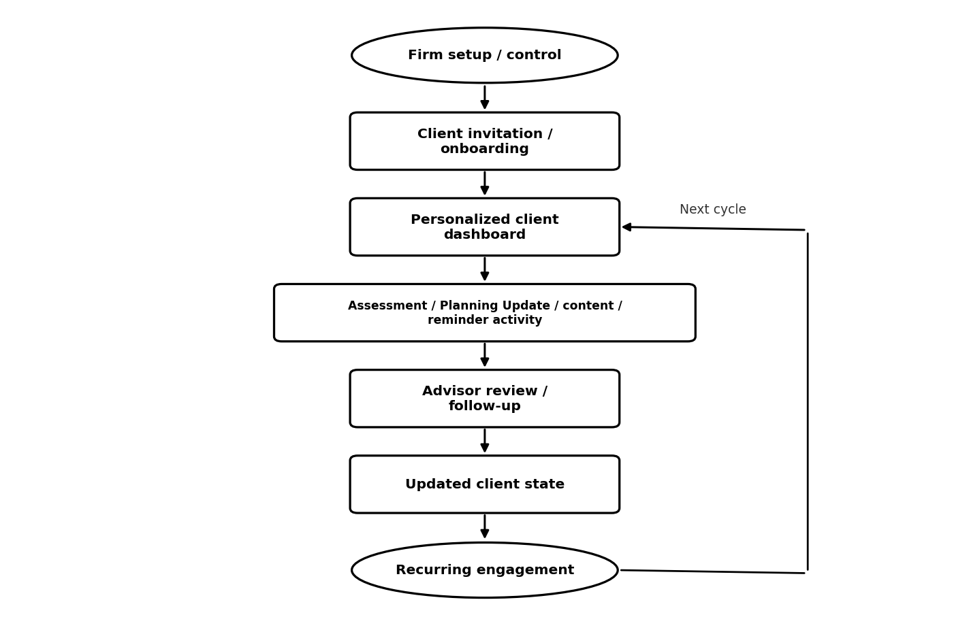

Capability | First-Build Product Requirement
Identity & tenancy | Secure roles, tenant boundaries, user status, correct firm/advisor relationships.
White label | Basic firm name/logo and selected advisor/brand identity.
Client onboarding | Invitation, activation, minimum profile/consent, first dashboard.
Client dashboard | Status, priority items, next action, activities, relevant content, reminders, advisor identity, continuity.
Assessments | Small fixed initial set, readable results, defined scoring/category logic, advisor cue.
Planning Update | Core due-to-follow-up workflow with simple state/change model.
Personalization | Simple explicit rules using validated context, assignments, state/history and firm controls.
Content | Platform-provided content, basic tags/relevance, firm visibility, advisor recommend/assign if validated.
Reminders / communications | Limited triggers and delivery; Automatic/Approval/Off; basic history.
Advisor experience | Assigned-client dashboard, exceptions, review/follow-up, communication/activity context.
Firm administration | Users, basic branding, feature/content/communication controls.
Platform administration | Tenant setup/status, platform content/configuration, operational oversight.
Benchmarking | Simplified display only if method/data/privacy are validated.
Audit/history | Basic workflow/communication/admin history required to support operations and continuity.
Integrations | No external integration is assumed required by Task 2. Preserve future readiness in technical architecture.

